**Exp. 1 Design an LED flasher**

**Circuit Diagram**

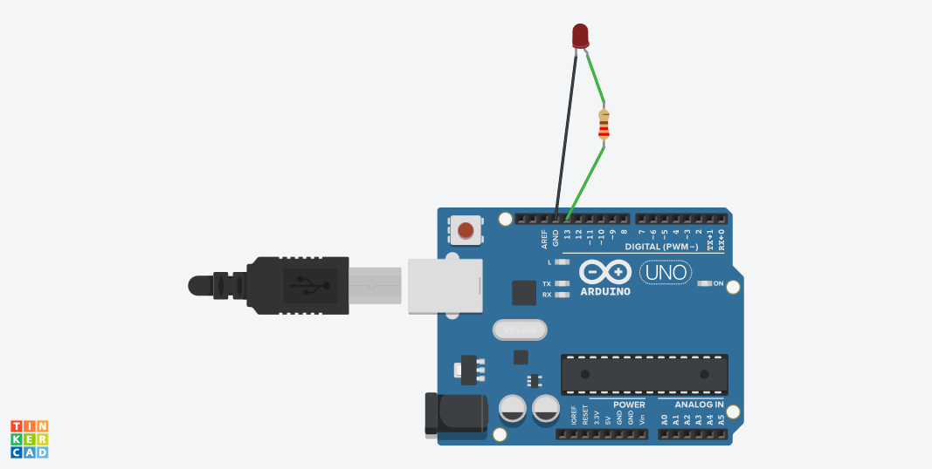

**Theory**

**Concept Used :** LED flashers are semiconductor integrated circuits used to turn on and off groups of light emitting diodes either sequentially or according to a programmed pattern. They are found in circuits used as indicators and controllers, as well as in home-built projects.

**Learning & Observations:** From this experiment we observe that led blinks at different frequency means that led gets high and low after certain delays such as in experiment we saw that led is delay for an interval of 1000ms.

**Problems & Troubleshooting:-**

**1)** Improper connection of ardiuno with the voltage supply (as in this case improper connection of ardiuno with the USB cable).

>>checking the USB connecting of cable and the computer**.**

2) Placing the LED in incorrect order.

>>Checking the led with multimeter and placed it in correct order.

**Precautions :-**

1) Check all the connections.

2) Check all the devices with multimeter whether they are working or not.

**Learning Outcomes:-**

1) Gets hands on ardiuno board .

2) Led blink with the help of ardiuno.